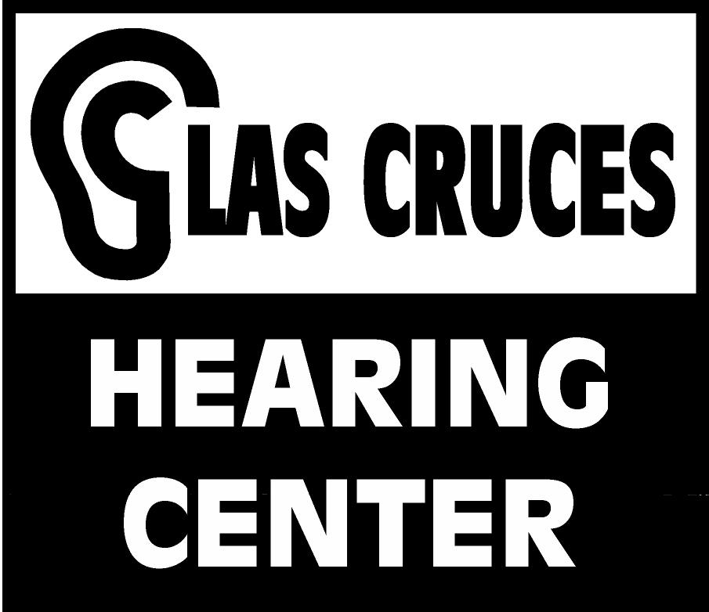

Pediatric Case History

Name: ____________________________ DOB: _________________

Parents’ Names: ____________________________________________

Referring Physician: ________________________________________

Primary Complaint: ______________________________________________________________

Has your child had a hearing test in the past? YES NO
If Yes: Location and Date of test: _______________________ Results: ___________________________________________

Has your child had ear infections in the past? YES NO
If Yes: At what age did the ear infections first occur? __________
How many ear infections have occurred in the last six months? ______
Has your child had tubes in the ears? _______ How many times? ______
Have antibiotics been used to treat ear infections? ______

Does your child have a history of excessive wax in ears? YES NO
If Yes: Describe how this is treated and how often: ________________________
___________________________________________________________

Has your child ever had surgery? YES NO
If Yes: Describe: ____________________________________________________
___________________________________________________________

Has your child had any illnesses or medical conditions? YES NO
If Yes: Describe: ____________________________________________________
____________________________________________________________

Has your child been hospitalized in the past? YES NO
If Yes: Describe why and when: ________________________________________
____________________________________________________________

Is your child currently taking any medications: YES NO
If Yes: List medications and dosages: ___________________________________
___________________________________________________________
___________________________________________________________

Please describe your child’s speech and language development (Do you believe it is normal? Why or why not?): _________________________________________________
_______________________________________________________________________

Please describe your child’s physical/motor development (Do you believe it is normal? Why or why not?): _____________________________________________________________
________________________________________________________________________

Please describe how your child performs at school: _______________________________
_______________________________________________________________________

Do your child’s teachers have any complaints about his/her listening behaviors? YES NO
If Yes: Describe: ____________________________________________________
____________________________________________________________

Does your child require speech therapy or any other special services? YES NO
If Yes: Describe: ____________________________________________________

Is there a family history of hearing loss? YES NO
If Yes: Please list relation to child and age of onset (if known): ________________
____________________________________________________________

Do you believe your child has a hearing loss? YES NO
If Yes: Describe why: _________________________________________________
____________________________________________________________

Please answer the following questions about pregnancy and birth:

Was the pregnancy normal? YES NO
If No: Describe: ______________________________________________________
_____________________________________________________________

Were there any complications during or after delivery? YES NO
If Yes: Describe: _____________________________________________________
____________________________________________________________

Was your child full term at birth? YES NO
If No: Describe: _____________________________________________________

What was the weight and length of your child at birth? _____________________________

Is there any other information that you would like to include? _______________________
____________________________________________________________________________

